# ST.XAVIER’S COLLEGE

# MAITIGHAR, KATHMANDU



**ASSIGNMENT #7**

**Database Management System**

**Submitted By:**

Pratibha Panta

012BSCCSIT028

4th Sem, 2nd Year

**Submitted To:**

______________________

Er. Sanjay Kumar Yadav

Department of Computer Science

Lecturer

1. Find the eno, ename of the employee whose salary>4000.

select eno, ename,salary from Employee where salary>4000;

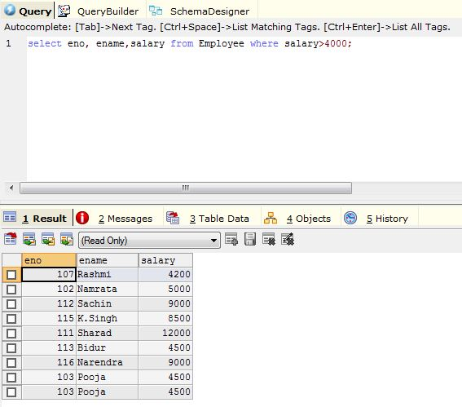

find the eno,ename,salary of the employee whose department number is 20 or job status is research fellow.

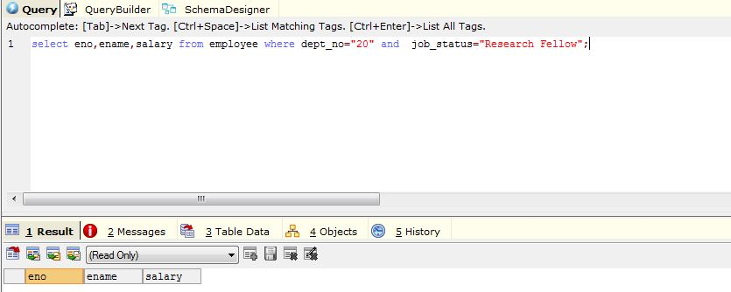

Combining conditions and Boolean operations

2. Find the eno,ename,salary of the employees whose salary > 5000 and job status is professor

select eno, ename,salary from Employee where salary>5000 and job_status="Professor";

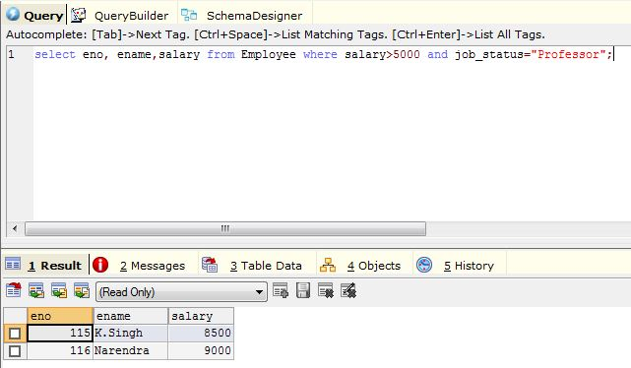

3.Removing duplications{ Select duplicate address from employee}

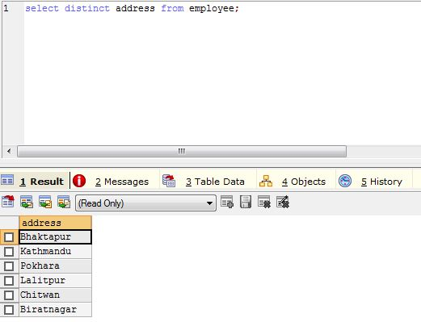

4.Range specification (In AND betn (where age betn 30 AND 40))

Find the eno,ename,age and salary from the employees where the age is betn 24 and 28.

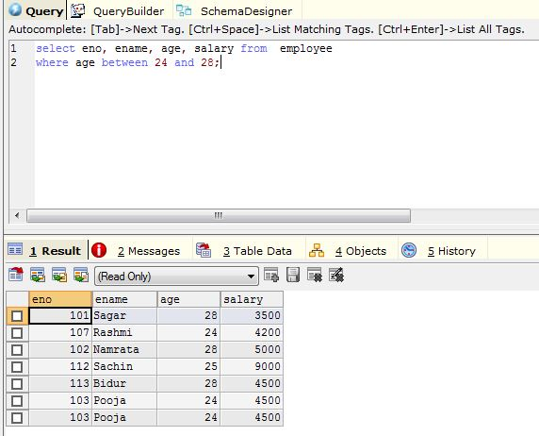

5. String operations

“ABC%”: all strings that start with ABC eg ABCD and ABCABC, they both satisfy the condition.

“%XYZ”:all string that end with XYZ. for eg WXYZ and ZZXYZ.

“%AN%”:All string that contain the pattern AN anywhere. eg LOS ANGELS and SAN FRANCISCO.

find eno,ename whose starting letter “Sa”.

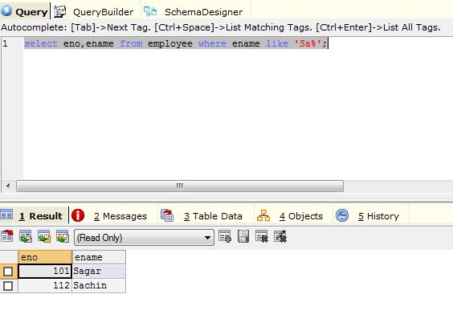

6. List all employee names with their project name.

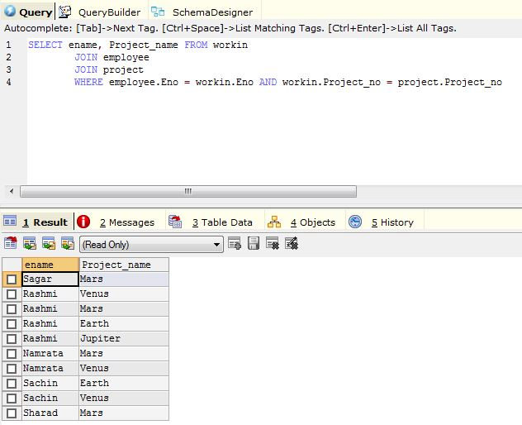

7. list name of all employee and their salary who are working in project “Mars” or “Venus”

8. list name of all employee and their salary who are working in project “Earth” and “Venus”.

9. list name and address of all employees who works in department which is located in pokhara.